This laboratory assignment accompanies the book, [*Embedded Systems: Real-Time Interfacing to ARM Cortex M Microcontrollers, ISBN-13: 978-1463590154*](https://www.amazon.com/Embedded-Systems-Real-Time-Interfacing-Microcontrollers/dp/1463590156), by Jonathan W. Valvano, copyright © 2021.

## Goals

* To interface two DC motors using PWM so software can adjust delivered power
* To interface two tachometers using input capture so the software can measure speed
* To implement the digital controller processing with periodic interrupts
* To study the behavior of the system as parameters to the proportional-integral (PI) controller are adjusted
* To implement a Command Line Interpreter (CLI) that allows the operator to set controller parameters and to display the status of the motor when it is running.

## Responsibilities:

* Student 1: Motors and interface hardware and PWM outputs
* Student 2: Tach hardware and input capture measurement of two speeds
* Student 3: Digital Controller
* Student 4: User interface (CLI) via a UART to PC interface.
* ALL: Tinker with variations of the PI control loop

**Team Size: 4**



Figure 8.1: Lab 8 Block Diagram (there are two motors).

## Review

* Valvano Section 6.1 about using input capture to measure period
* Valvano Section 6.3 about generating PWM outputs
* Valvano Section 6.5 about interfacing a DC motor with a DRV8847
* Pololu motor <https://www.pololu.com/product/3675>
* Valvano Section 6.6 about proportional integral control
* Control Station notes from BYU [proportional control](https://www.et.byu.edu/~tom/classes/436/ClassNotes/Class07-PI.pdf)

## Starter projects

* PWM_4C123
* PeriodMeasure_4C123
* InputCapture_4C123
* Lab8
* PeriodicTimerxAInts_4C123 (Timers x=0, 1, 2, 3)
* RSLK KiCad Schematic and PCB files
* ECE445M RTOS_MotorTestProject

## Required Hardware

EK-TM4C123GXL [https://store.ti.com/](https://store.ti.com/ProductAccessories.aspx?ProductId=4505) $16.99

RSLK2 Robot, see RSLK2_BOM.xlsx

## Background

The advantages of DC motors include low cost, high speed, and high torque. However, they need sensors and closed-loop controllers to operate them with predictable responses. Applications of DC motors include electric cars, robotics, industrial machines (pumps, drills, mills, and lathes), consumer products (blender, washing machine, and AC/heaters) and medical devices (pumps). In this lab, you will spin two brushed DC motors (Figure 8.2) at a constant speed using a proportional-integral (PI) controller. The user interface will allow the operator to increase or decrease the desired speed. Two tachometers will be used to measure the motor speeds. A background periodic interrupt will execute the three steps of a digital controller.

1. Calculate error as the difference between actual and desired speed
2. Execute a control equation to determine the next output
3. Adjust the power to the actuator to drive the error to zero

The software will set the power delivered to the motor using pulse-width-modulation (PWM). The essence of an integral controller is the amount you add to the power is linearly related to the error. If the motor is spinning much too slowly, you will increase power a lot. If the motor is spinning just a little bit too slowly, you will increase power a little bit. If the motor is spinning much too quickly, you will decrease power a lot. If the motor is spinning just a little bit too quickly, you will decrease power a little bit. The input capture input and the PWM output must be written at a low level, like the book, without calling TivaWare driver code. No TivaWare code is allowed.

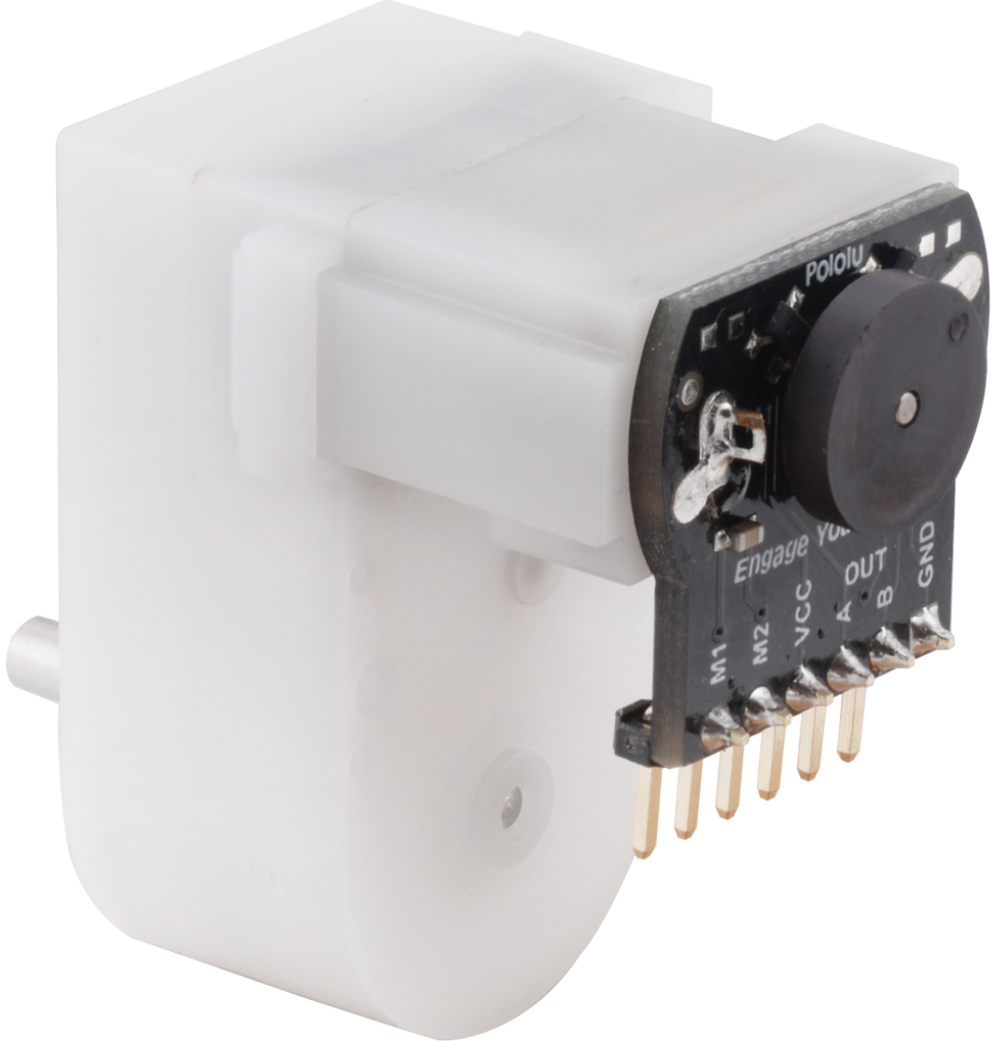 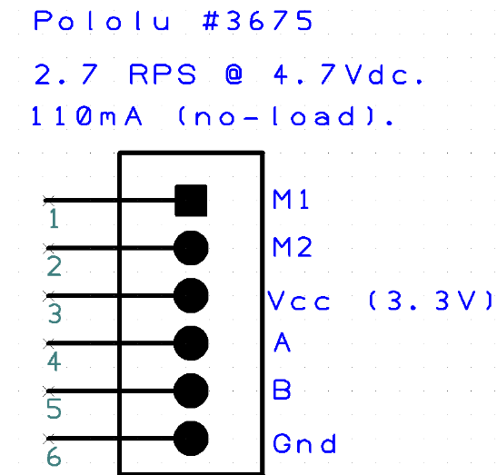

Figure 8.2. RSLK robot uses two Pololu item #3675. M1 and M2 connect to the DC motor and the other four wires are the tachometer.

Figure 8.3 shows a simple data flow graph. Two tachometer sensors create square waves depending on the two motor speeds. Input capture interrupts measure left and right motor speeds. These data are fed to the motor controller, which adjusts the left and right duty cycles in attempt to spin both motors at the same speed. The two PWM duty cycles are fed to the H-bridges to set the power to the two motors. If successful, the robot should move in a straight line.

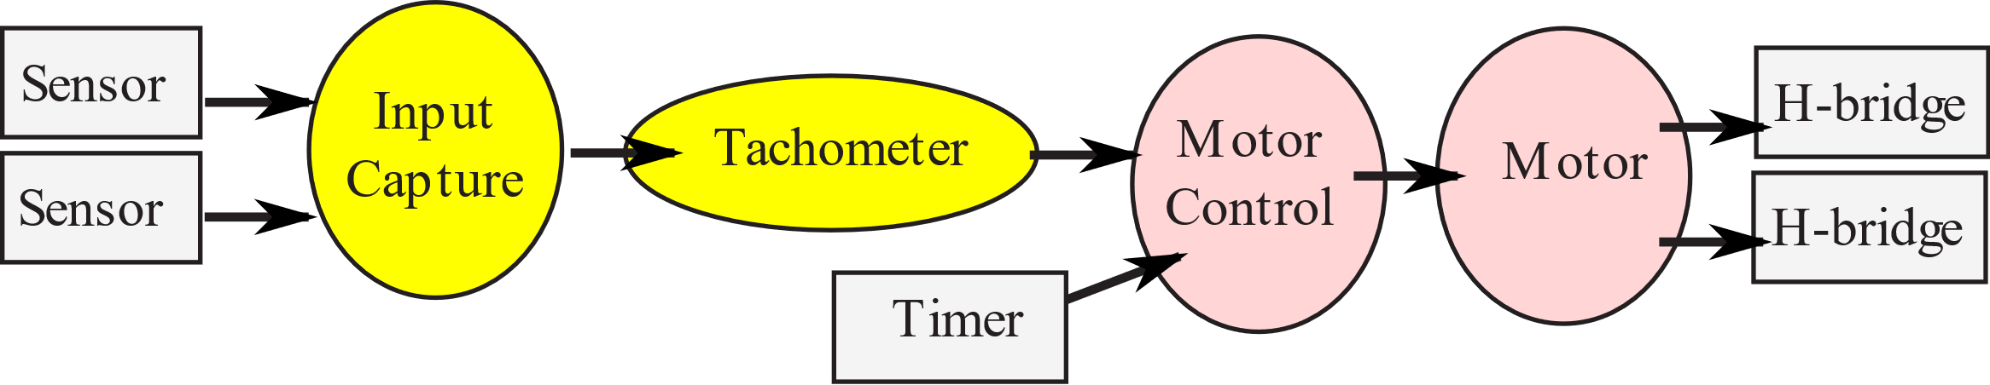

Figure 8.3. Simple data flow graph.

Figure 8.4 shows a more complex data flow graph. The operator on the PC can set the desired speed and controller parameters. If the robot triggers one of the four bump switches, the two motors should stop. System parameters can be observed on the PC and the OLED.

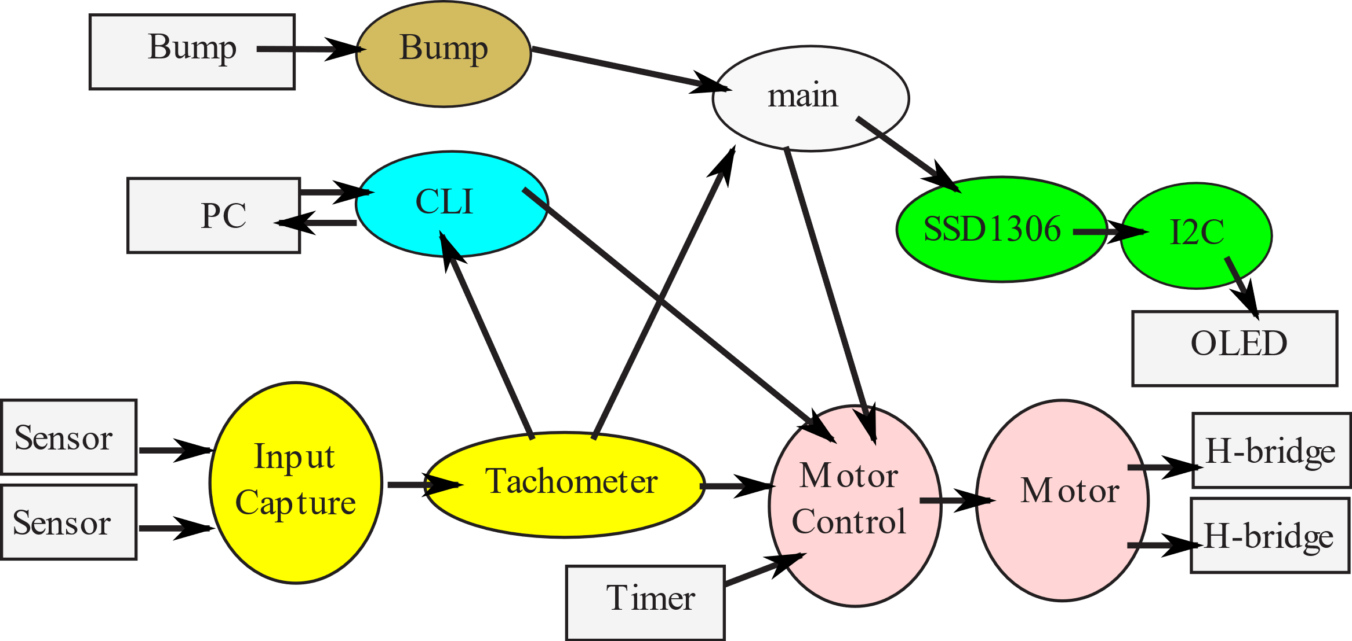

Figure 8.4. More detailed data flow graph.

Figure 8.5 shows a possible call graph. You are free to solve Lab 8 with whatever data flow graph or call graph as you which. Recall however, that modularity maximizes the number of modules and minimizes the coupling. **Bandwidth coupling** is defined as the amount of data flowing through the arrows of the data flow graph. **Invocation coupling** is defined as the number function calls occurring in the call graph over a fixed time interval.

*Note*: it is very bad style to connect modules using the **extern** modifier. Using **extern** creates a coupling that is hard to manage and impossible to quantify. If you find it impossible to solve a system without **extern**, then consider merging the two modules into one.

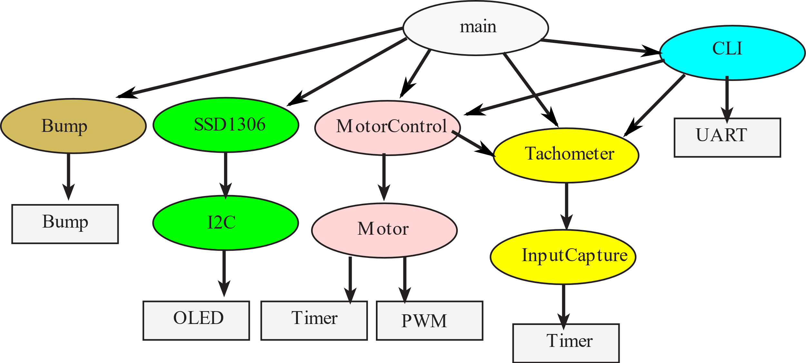

Figure 8.5. Possible Lab 8 call graph.

## Student 1: Motor interface with PWM output

Program 8.1 shows the motor pins on the RSLK2 robot.

**// TM4C MSPM0**

**// PF2 PB4 Motor_PWML, ML+, IN3, PWM M1PWM6**

**// PF3 PB1 Motor_PWMR, MR+, IN1, PWM M1PWM7**

**// PA3 PB0 Motor_DIR_L,ML-, IN4, GPIO 0 means forward, 1 means back**

**// PA2 PB16 Motor_DIR_R,MR-, IN2, GPIO 0 means forward, 1 means back**

Program 8.1. Motor pins on the RSLK2.

You must use a TM4C123 LaunchPad because the LM4F120 microcontroller does not have hardware PWM. The L293D H-bridge has built-in shunt diodes to remove voltage transients caused by the inductance of the motor. Figure 8.6 shows the voltage transients can occur both when the power is applied and when it is removed. *Note*: V = L dI/dt depends on inductance L and the speed of the driver. Depending on the speed of the H-bridge and inductance of the motor, this peak can reach 100s of volts

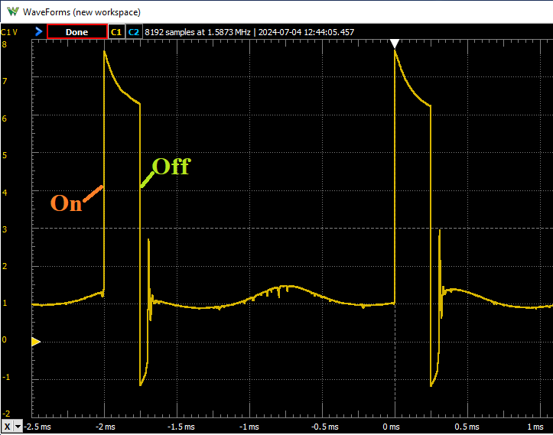

Redo

Figure 8.6. Voltage measured on the DC motor ML+ and ML- with shunt diodes.

To choose a PWM period you will need to know the time constant of your motor. Figure 8.7 is measured speed as a function of time as PWM is increased from 25 to 50%. You can estimate the time constant of this motor to be about 50 ms. Therefore, if the PWM period is 2 ms, the motor will only respond to the average power (duty cycle), and not to the individual high and low signals of the interface.

Redo

Figure 8.7. Step response of the DC motor used to estimate the time constant. This data was collected at 7.2V.

Figure 8.8 shows two PWM outputs with a period of 2 ms. When the controller is running the two PWMs will have different duty cycles, because the controller will adjust the PWMs so each motor spins at the same speed.

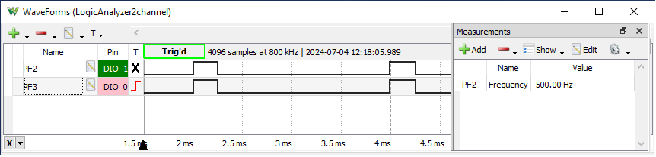

Figure 8.8. Two PWM outputs allow the system to adjust power to the motors.

## Student 2: Tach hardware and input capture measurement of speed

Program 8.2 shows the tachometer pins on the RSLK2 robot. The tachometer is interfaced to PB7 (TOCCP1) and PB2 (T3CCP0).

**// TM4C MSPM0**

**// PB7 PB8 ELA T0CCP1**

**// PB2 PB12 ERA T3CCP0**

Program 8.2. Tachometer pins on the RSLK2.

There is a 4.7k pullup to 3.3V for the tachometer signals ELA and ERA. The motors have a gear box, so there are 360 tach pulses per rotation. Figure 8.9 below shows a tachometer frequency of about 1kHz. This corresponds to a motor speed of

(1000 pulses/sec)*(1 rotation/360 pulses)*(60 sec / 1 min) = 166.7 RPM

Assume the input capture resolution is 12.5ns. The raw input capture period measurement for the 1 kHz input will be 80000 bus cycles. Using a similar equation, we can calculate the motor speed as

(80,000,000 bus cycles/sec) *(60 sec / 1 min) *(1 rotation/360 pulses) /(80000 bus clocks/pulse)

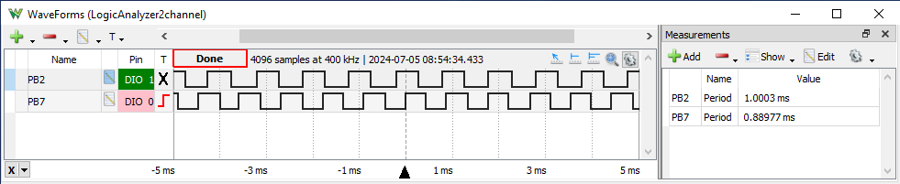

Figure 8.9. Tachometer output at full speed.

The tachometer interface may require analog or digital filtering to improve SNR. However, be careful to minimize time delay. Time delays in the tachometer measurement may cause the controller to be unstable. For any digital filter, measure the step response. A simple measure of filter delay is to make input go from …x,x,x,x,y,y,y,y… and determine many samples it takes for the output of the filter to reach x+(y-x)e-1. For example, the delay of a 5-wide median filter is 3 samples.

You will need a separate periodic task to determine if the motor is spinning too slow to be accurate or not spinning at all.

## Student 3: Digital Controller Design

A closed loop feedback is required because not all motors are created equal. One of the first steps in designing a digital controller is to make an estimate of motor speed in RPM versus PWM duty cycle. This curve will help estimate the range of speeds that your controller will be able to manage. In other words, what speeds correspond to duty cycles from 25 to 75%? Note: this response is highly dependent on friction. We expect the usable range to be around 40 to 120 RPM, but your motors may be different. The design progression is

1. Incremental (stable but slow)
2. Integral (stable, a little faster)
3. Proportional-integral (may be unstable, fast)

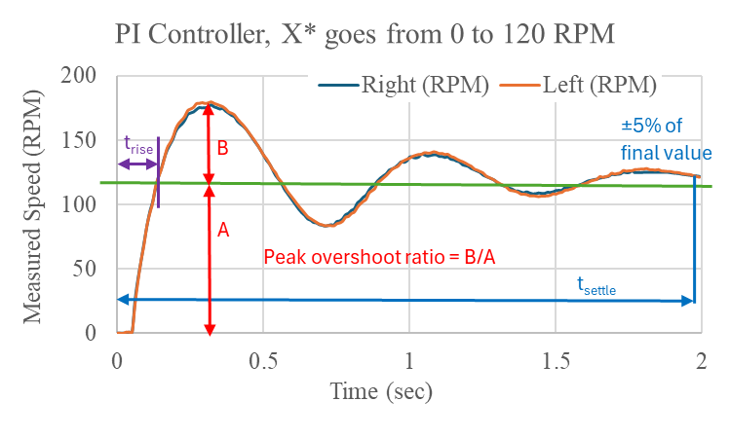

Figure 8.10. PI Controller Response showing underdamped behavior.

## Student 4: UART <-> Command Line Interpreter (CLI) -> Motor Control

Create a mechanism to visualize and control the system using a Command Line Interpreter (CLI) connected to a UART port on the TMC4. See the requirements document in the **Lab8Report** for details.

## Preparation (do this before your lab period)

1. Edit the requirements document in the **Lab8Report** as needed. Assign team members to each task. The requirements document is meant to be fluid. Therefore, you should be editing it as you develop this robot controller.
2. Remove R9 and R10 from your LaunchPad.
3. Review the RSLK design documents. Understand the microcontroller pin assignments. Notice how the robot is powered in debug mode and how it is powered in stand-alone mode.
4. Charge the 6 batteries, and then run the RSLK test project to make sure the motors and sensors are operating properly.
5. Design four software modules that implement the robot controller. More specifically, edit the four header files to reflect your design:

* **Motor.h** PWM outputs to PF2 PF3, GPIO outputs to PA3 PA2
* **Tachometer.h** Input capture inputs on PB7 PB2, GPIO inputs on PB6 PA3)
* **MotorControl.h** Review the linkage to the other modules
* **CLI.h** UART I/O for operator control

## All Students Procedure (do this during your lab period)

Perform all testing and measurements with the robot positioned so the wheels do not touch the ground.

## 

## Student 1 Procedure (do this during your lab period)

Develop and test software that creates the two PWM outputs with a fixed period anywhere in the range of 1 to 5ms. With a two-channel scope or logic analyzer, measure the outputs on PF3 and PF2, like Figure 8.8.

Measure +7.2V with a DVM. With a two-channel scope, measure the analog voltage on MR- and MR+, like Figure 8.6. Calculate the voltage drop lost in the motor driver chip. Calculate the DC voltage, *Vm*, applied to the motor when on (MR+ high, MR- low).

Using a DVM, measure the +7.2V current, *Im*, (to entire robot) when one motor spins at 0%, 25%, 50%, and 75% duty cycle. Please contact your professor or TA if this current is vastly different from 120mA. Subtracting off the current at 0%, estimate the motor power in watts for 25%, 50%, and 75% duty cycle.

*Pm*(duty) = *Vm* *(*Im*(duty) - *Im*(0)), where duty ={0%, 25%, 50%, and 75%)

Create a graph similar to Figure 8.11 below. Does the data suggest the motor could be modeled as a simple resistive load?

Redo

Figure 8.11: The power to one DC motor is plotted versus duty cycle. Notice the DC motor does not behave like a resistor. This response will also be a function of the mechanical torque (or friction) applied to the shaft.

## Student 2 Procedure (do this during your lab period)

Using a 2-channel scope, verify the tachometer generates digital signals like Figure 8.9.

Develop and test the tachometer software that performs the left and right speed measurements. Speed measurement must occur in the background using an input capture and periodic interrupts.

An extra pulse (glitch) will create two short input capture measurements and generate two large speed calculations. If you are getting extra pulses, observe the signal with a scope and add analog, digital, or software filtering. At a constant duty cycle the speed measurements should be stable.

Using the PWM output in open loop fashion measure the motor speed at duty = {0%, 25%, 50%, and 75%). Do this under no load. Estimate the average motor power as *Im*\**Vm*. Create a graph similar to Figure 8.12 below.

Redo

Figure 8.12: The motor speed is plotted versus applied power on seven different motors. Power is motor voltage multiplied by motor current multiplied by PWM duty cycle. Notice at xx mW, these DC motors do not spin at all. Also notice the variability between these seven motors. This response will also be a function of the mechanical torque (or friction) applied to the shaft.

## Student 3 Procedure (do this during your lab period)

After you are sure the motor and tachometer interfaces are operating properly, test a simple incremental controller, see Figure 8.13. Choose a PWM period, a range of usable speeds, and a controller rate consistent with the data collected in the above two procedures.

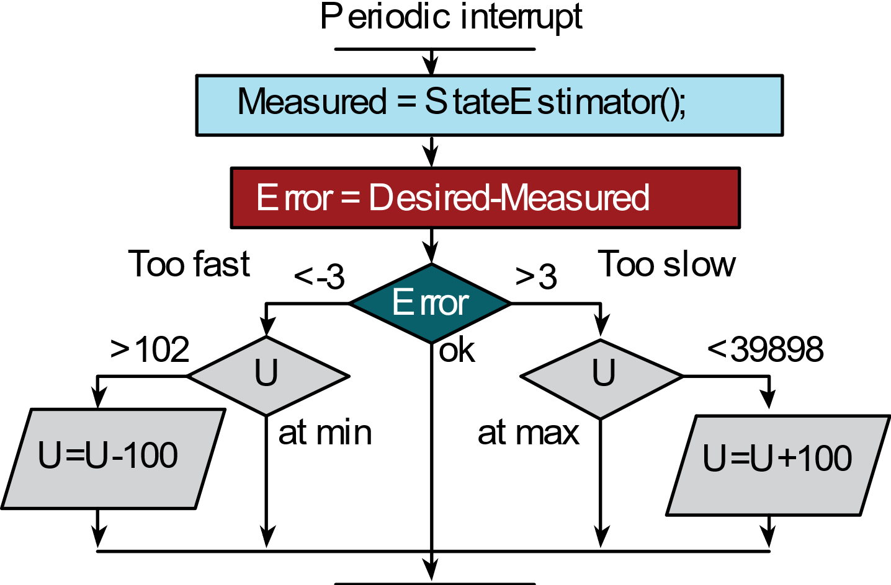

Figure 8.13: Incremental controller. Change any of these constants as you wish.

Debug the integral motor controller. The periodic interrupt-driven background thread will execute the digital controller, while the foreground thread initializes the system then performs human interface. An integral controller will be stable. If the speed oscillates wildly (all stop- full speed) then decrease the controller constant. If it is VERY slow to respond, increase the constant.

Debug the PI motor controller. Review this [proportional control](https://www.et.byu.edu/~tom/classes/436/ClassNotes/Class07-PI.pdf) PowerPoint from BYU to understand controller design and performance metrics

* Rise time
* Setting time
* Peak overshoot Ratio

## Student 4 Procedure (do this during your lab period)

Student 4 creates a mechanism to visualize and control the system using a UART connected to a PC using PUTTY (or similar terminal emulator). See requirements document for details. Measure speed versus time immediately after the set point is changed. See Figure 8.10.

## All Students Procedure (do this during your lab period)

Pick one change that is most interesting to the group (e.g., 0 to 120 RPM, 50 to 100 RPM, etc.) Collect the speed versus time response of the system for four PI controller settings (like Figure 8.10)

* Overdamped
* Optimally damped (your best effort)
* Underdamped
* Unstable

Calculate rise time, settling time, and peak overshoot ratio for the three stable settings. Figure 8.14 through 8.17 show responses from last year’s lab setup. You do not need to plot speed versus time on the display. See also the YouTube video, <http://youtu.be/ug-ZlOSbb4M>.

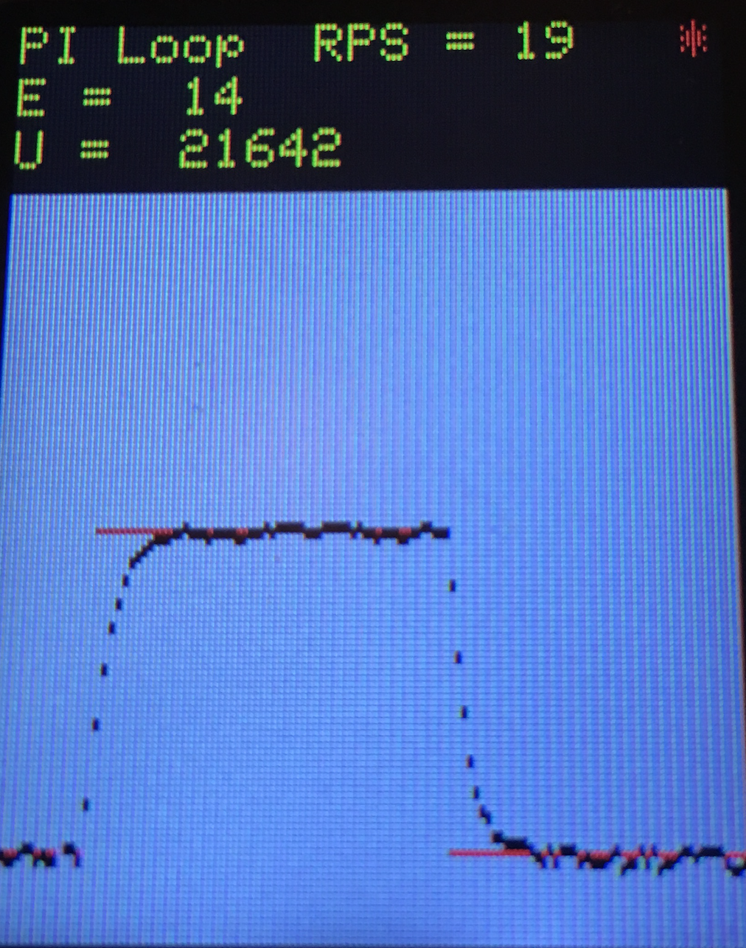

RED: Desired Speed

BLACK: Actual Speed

Figure 8.14: Measured and desired speeds are plotted versus time as the set point is increased from 20 to 50 RPS. NOTE: This is an optimally damped PI Loop (Lab board motor)

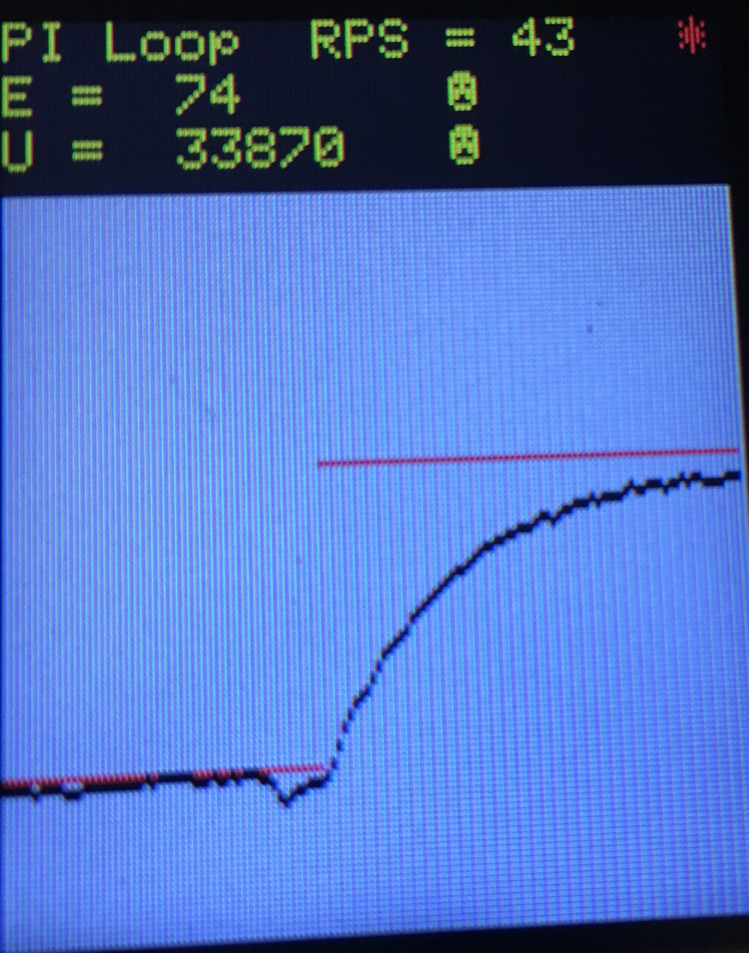

RED: Desired Speed

BLACK: Actual Speed

Figure 8.15: Over-damped PI Loop

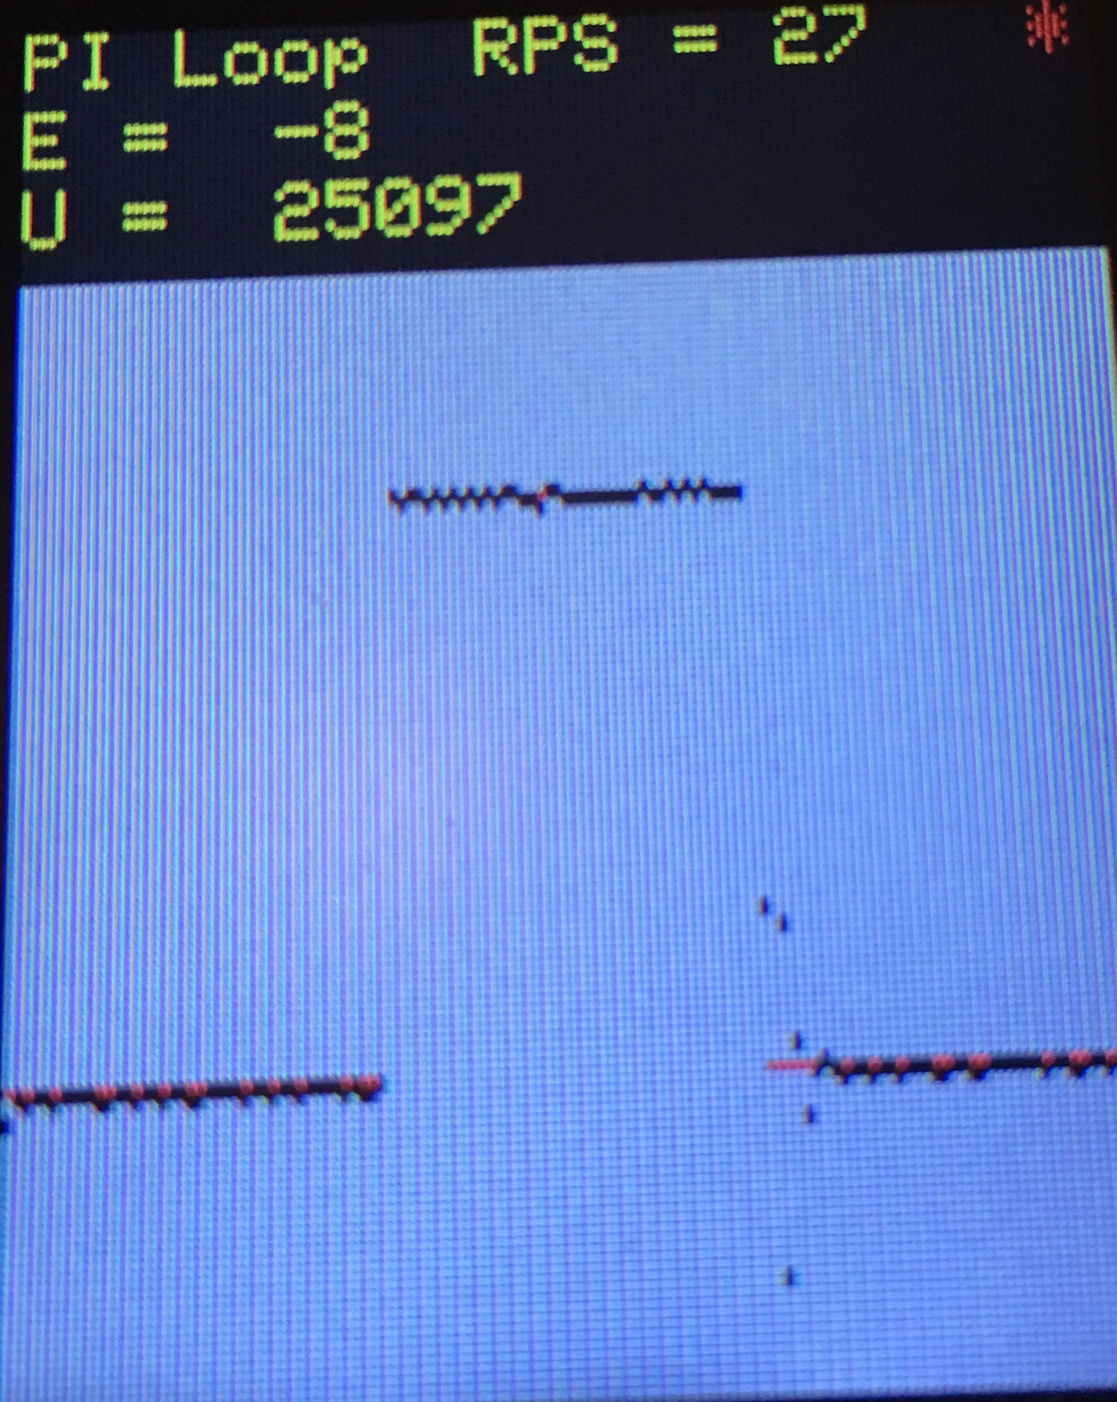

RED: Desired Speed

BLACK: Actual Speed

Figure 8.16: Under-damped PI Loop

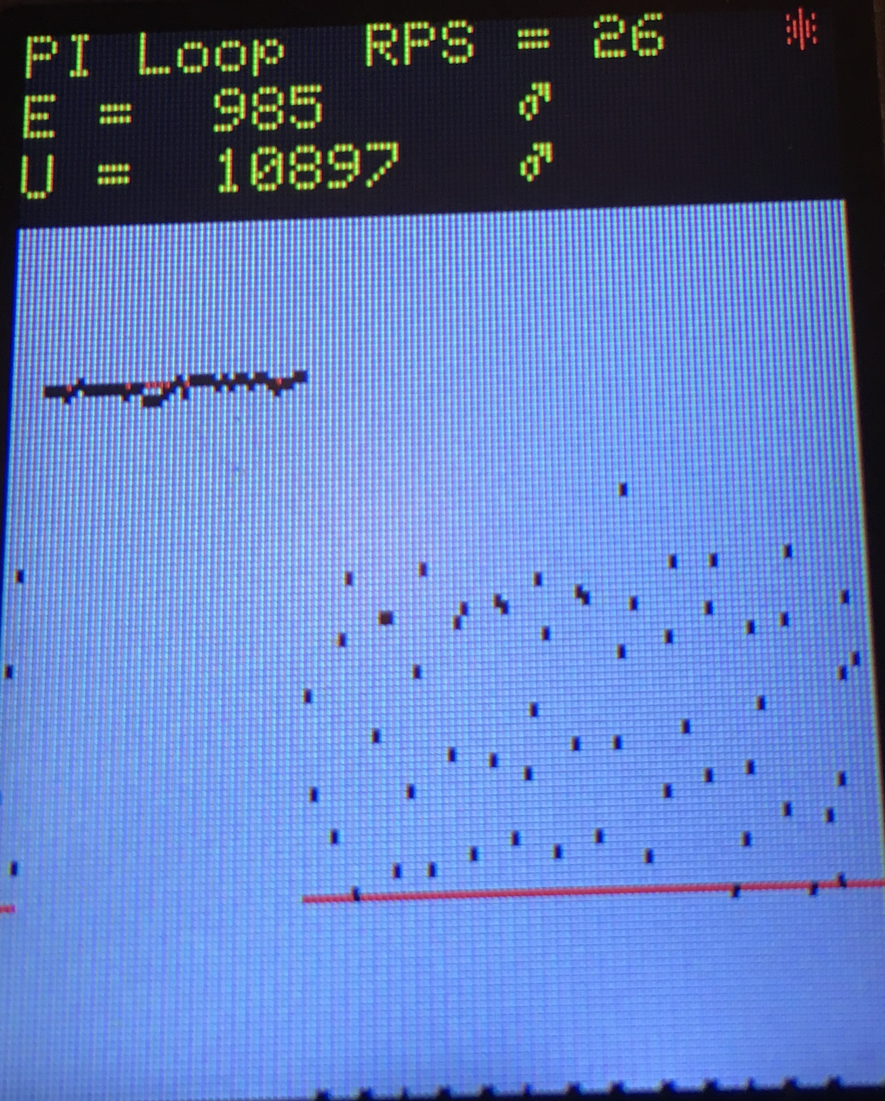

RED: Desired Speed

BLACK: Actual Speed

Figure 8.17: Unstable PI Loop

The CLI user interface should facilitate changing controllers and controller parameters. You should be able to demonstrate without recompiling.

## Student-all Procedure (do this during your lab period)

Measure the maximum time to execute each of your ISRs. Calculate CPU utilization for each task (motor control, tachometer, and main). Ignore the CLI and the UART communication to the PC

For each of the three controllers, what is the average controller error (difference between desired and actual speed)?

For each of the three controllers, after a change in set-point, you will measure rise time, settling time, and peak overshoot ratio. Feel free to change these two set points that is appropriate for your system. You do not need to tweak the system to minimize error or response time.

Measure the total system current running both motors at top speed.

## Deliverables (exact components of the lab report)

1. Objectives (final requirements document)
2. Hardware Design (PCB Artist file)

DC motor and tachometer interfaces, showing all external components

LCD and switch interfaces, showing all external components

Include both these in a schematic

1. Software Design (upload your files as instructed by your TA)

Make sure to include units on all your software variables

Make a clear distinction between variables used for debugging and variables needed in the controller

Data flow and call graph: copy Figures 10.3 and 10.4, and edit as necessary

1. Measurement Data (underlined sections of the lab manual)

Procedure 1) Give the voltage, current, and resistance measurements. Plot motor current vs *duty*\**Vm*.

Procedure 2) Typical plot of the tachometer like Figure 10.7. Motor speed vs PWM. Plot of motor speed vs power, like Figure 10.8.

Procedure 3) We define **locking** as the condition when the error eventually goes to approximately zero. Four screen shots of the hardware in operation -> switching from minimum speed to

maximum speed or vice versa:

a) Normal operation – optimal response time (locking). Fig 10.11

b) Slow loop response time (locking) Fig 10.12

c) Fast loop response time (locking) Fig 10.13

d) Unstable (unable to lock) Fig. 10.14

Procedure-all) Specify the maximum time to execute once instance of the ISR. Determine the percentage time required to run all ISRs.

Procedure-all) Specify the average controller error for three controllers

Procedure-all) Specify the approximate response time for three controllers

1. Analysis and Discussion (give short one or two sentence answers to these questions)
2. What is torque? What are its units?
3. Draw an electrical circuit model for the DC motor coil and explain the components. Use this circuit model to explain why the current goes up when friction is applied to the shaft
4. Explain what parameters were important for choosing a motor drive interface chip (e.g., IRLD024/IRD120). How does your circuit satisfy these parameters?
5. You implemented an integral controller because it is simple and stable. What other controllers could you have used? For one other type of controller how would it have been superior to your integral controller.
6. It the motor is spinning at a constant rate, give a definition of electrical power in terms of parameters of this lab? Research the term “*mechanical power*”. Give a definition of mechanical power. Are the electrical power and mechanical power related?

## Checkout (show this to the TA)

You should be able to demonstrate correct operation of the DC motor system. Be prepared to describe how your motor interface works. Demonstrate debugging features that allow you to visualize the software behavior. Show the TA the four modes specified in the Deliverables Section-4: Normal operation, Slow loop response time, Fast loop response time and Unstable mode.

All software and report files must be uploaded as instructed by your TA.

## Hints

1. You should use a periodic interrupt to determine if the motor is stopped or spinning very slowly.
2. The USB +5V regulated supply is specified to 500 mA total current. We strongly suggest you do not mechanically load the motor. It runs 120 mA unloaded, but much larger if you load the motor. If your PC disconnects you, then you will need to power cycle your computer and restart the OS.